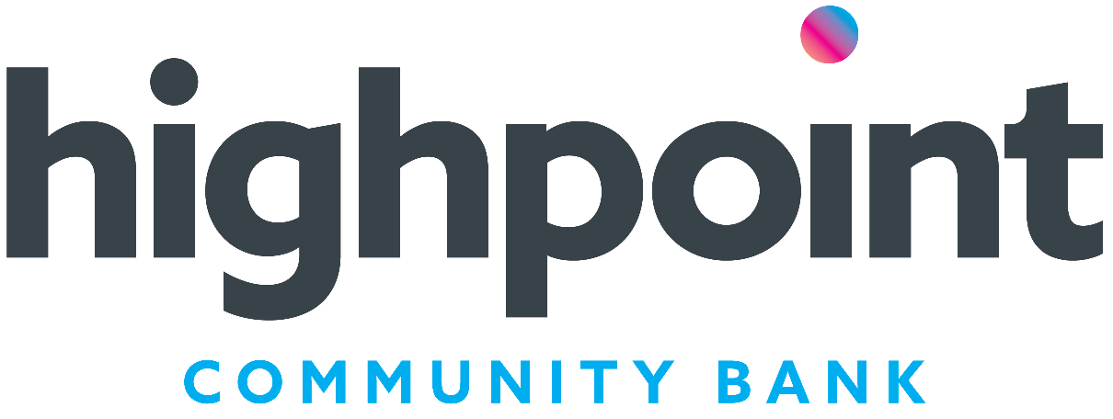

150 West Court St.
Hastings, MI 49058
www.highpointcommunitybank.com
269-945-2401
FAX: 269-945-6337

Request for Donation

Highpoint Community Bank believes in giving back to the communities we serve. We focus our charitable giving on community programs with an emphasis on service to youth and building healthy communities.
Name of organization:
501(C) (3) non-profit tax-exempt organization: □ Yes □ No
Mailing address:
City, State, Zip:
Telephone/Fax number:
E-mail address:
Contact person:
Check should be made payable to:
Describe what the request is for:

Date when the money is needed: __________________Amount requested:
Have we supported this event in the past? □ Yes □ No If Yes, when / amount
How will this contribution be recognized?________________________________________________________
Logo required: □ Yes □ No
Color _____B&W______Size and format required:_________________________________________________
Does the organization have an account relationship with our bank? □ Yes □ No
Are you aware of any current Highpoint Community Bank employee / director involvement in the organization?

What are the benefits to our community if this request is approved? How is success measured in your organization? Feel free to attach any supporting documents.

For Bank Use Only:
Approved: Yes No By __________ Amount: ___________
Follow-up: _________________________________________

Signature Date

Please return this completed request thirty (30) days in advance to:
Attn: Laurie Ann Curtis Highpoint Community Bank, 150 West Court St., Hastings, MI 49058 or fax to 269-945-6337.

2/2019

